Who was George Orwell?
The Orwell Youth Prize takes its inspiration from the author, journalist, and essayist George Orwell.
By the time of his death in 1950, he was respected all over the world as a journalist and author: for his eyewitness reporting on war and poverty; for his political and cultural commentary, where he stood up to power; and for his fiction, including two of the most popular novels ever written: Animal Farm and Nineteen Eighty-Four. Phrases like ‘Thought Police’, ‘Big Brother’ and ‘Doublethink’? That’s all him!
Why is it The Orwell Youth Prize?
Orwell wrote from his own experiences and carefully observed what was going in the world around him. He also wrote in language that was clear, concise and compelling.
We encourage you to follow Orwell’s example in your own writing: to write about something that matters to you, and that you want to draw to the attention of others. Orwell wrote stories, essays, articles and even poems – which is why the Orwell Youth Prize encourages you to write in any form. We also have some advice on how to find a form which works for you.
You don’t need to write about Orwell, to have read his books, or know his biography. We just want you to be inspired by his commitment to write truthfully and clearly about issues he cared about.
Home – where to begin?
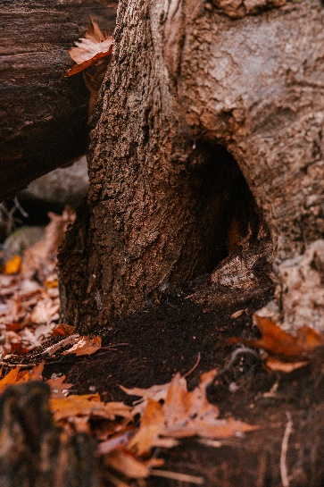

Whose home is this?
Pick one of the pictures above. Who or what might call this place home? This could be a human or an animal or even a supernatural creature, like a ghost or a vampire!
Think about:
- Why do they live there?
- Who do they live with – or do they live alone?
- What do they like about living there?
- What don’t they like?
Next, use the five senses to try to bring to life what this home is like for them:
- Start with sight – what does it look like? Think about colours, shapes, patterns, what they can see inside their home, and what they can see looking out from their home.
- Next, sounds – is their home peaceful and quiet or noisy and bustling? Think about sounds inside the home (maybe a ticking clock, a washing machine, laughter, or chatter) and also sounds from outside (weather, water, trees rustling, etc).
- What about smells? Are there plants in the house? What about cooking? Fresh laundry? Something specific to this particular home?
- Tastes… what food reminds this person/creature of home? Does their favourite food relate to their home? (e.g. fish they’ve caught from the river, acorns they’ve found in the woods?)
- And last but not least – touch and feel. There’s two parts to this one – firstly, what are the textures like in this house? Soft comfy armchairs, sharp-edged tables, fluffy rugs? Is it hot or cold? And secondly – what does it feel like to live here? Safe, comfortable, exciting, scary, lonely, peaceful?
Finally, turn all your ideas into a short story or poem about your character and their home! You might want to write about your character in their home, or what happens if their home is threatened, or if they have to leave it…or how they came to live here in the first place!

Dream Home
What would be your dream home?
1) Where would it be? It doesn’t even have to be in this world – it could be on another planet, somewhere in history or in the future, or in a fantasy world! You decide.
2) What does it look like? Is it a house, a castle, a caravan, a Hobbit house, a star, a giant peach?
3) Who would you live there with? Friends, family, celebrities, characters from books? What about pets? Or would you prefer to have the whole place to yourself? Who’s in charge in your house?
4) How do you end up living there? Do you win the lottery, make your fortune as a famous writer, or do you build it yourself? And what resources does this home depend on? (e.g. what fuels it, how do you keep it clean and tidy and safe, where does your food and water come from?)
5) What kind of society does your dream home exist in – what’s going on outside and around your home? Is it a fair or unfair society? Are there any risks or dangers to your home in this society – e.g. flooding due to rising sea levels, an evil leader who wants to turn your home into a factory? What would you do if your dream home was threatened? How would you protect it?
Write a story, poem, diary entry or newspaper article about you and your dream home.
The Orwell Youth Prize is open for entries to all secondary school students in the UK, in years 7-13. It’s free to enter, and entrants can submit writing in any form (poems, stories, articles, essays, letters, diary entries, scripts, etc) on the theme of HOME.
All entrants who enter their writing by Monday 1st April 2024 are offered personalised feedback on their entry. They can then resubmit a final draft by our final deadline of Monday 6th May.
Visit our website at www.orwellyouthprize.co.uk for more information and email Programme Coordinator Tabby Hayward at tabby.hayward@orwellfoundation.com with any questions.
Best of luck with your entry!

