These tasks will help you prepare a piece of writing to enter the

Orwell Youth Prize, on the theme for 2023
‘Who’s in Control?’
Lesson 4: Research

George Orwell did his own research. But he couldn’t rely on YouTube videos. Orwell stayed in the homes of the industrial working class in Depression-era Wigan; he worked among the poorest in London and Paris; he fought in the Spanish Civil War.

Don’t worry, though. No one expects secondary school students to travel so far, in space or time. Orwell was also very well-read, with a keen eye for what could be trusted and what was propaganda.

Where do I begin?
Society and Community  ‘Power is no more inherently good or evil than fire or physics. It just is.’  Eric Liu Ted Talk: Why ordinary people need to understand power  https://www.youtube.com/watch?v=Cd0JH1AreDw  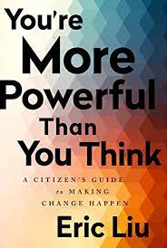  BBC article on influencer culture  https://www.bbc.co.uk/bbcthree/article/b5488f38-e9c4-4e0c-95e2-3002f47f88f8 | Environment  2022 Orwell Youth Prize judge Michael Jacobs’ article for Inside Story on What exactly is the point of COP27?  https://insidestory.org.au/what-exactly-is-the-point-of-cop27/  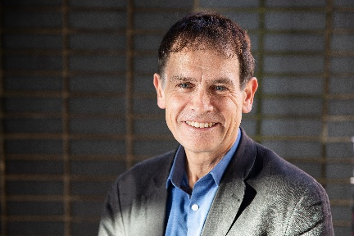  ‘You have stolen my dreams and my childhood’ –Greta Thunberg speech at the 2019 UN climate summit https://www.youtube.com/watch?v=TMrtLsQbaok
Politics and Economics  Watch this introduction to how the UK parliament works here: https://learning.parliament.uk/en/resources/introduction-to-parliament-primary-video/  An introduction to economics for young people: https://kids.britannica.com/kids/article/economics/353081 | Truth and disinformation  Why are conspiracy theories appealing to so many of us? https://fivethirtyeight.com/features/why-people-fall-for-conspiracy-theories/  And how to talk to someone who’s fallen down the rabbit-hole https://www.technologyreview.com/2020/07/15/1004950/how-to-talk-to-conspiracy-theorists-and-still-be-kind/
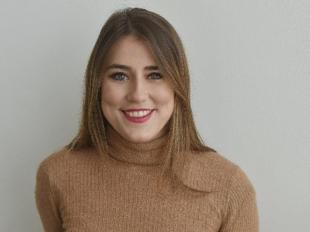
You have access to information with an ease and immediacy that Orwell could only have dreamt of. You are also exposed to misinformation in a way that Orwell did dream of … in his nightmares. Check out 2023 Youth Prize judge Marianna Spring’s Royal Television Society video on disinformation and online conspiracies here: https://www.youtube.com/watch?v=_yjzGgDO8cE and who starts viral misinformation here https://www.youtube.com/watch?v=UAy6PI5UtSU .

Before you research your topic for the Prize, carry out these exercises to help you prepare to get sound, useful information – and fight off the misinformation-makers who are everywhere out there, trying to mislead you.
“Every record has been destroyed or falsified, every book rewritten, every picture has been repainted, every statue and street building has been renamed, every date has been altered. And the process is continuing day by day and minute by minute. History has stopped. Nothing exists except an endless present in which the Party is always right.”
George Orwell, 1984

ACTIVITY

Use Michael Caulfield’s ‘Four Moves’ to assess information on the web.

- Choose two stories from his blog. https://fourmoves.blog/
- Then apply the SIFT technique to each story – and record your results in the table attached. https://www.notion.so/Introducing-SIFT-04db7879dd7a4efaa76bfb2397d11ffd

Research Activity: SIFT

Stop

Investigate the Source

Find trusted coverage

Trace claims, quotes, and media back to the original context

Stop! How do you feel about this story? | Investigate: what did you find out about the Source?
What better trusted coverage did you find?  In what ways was it a better source? | Were you able to trace claims, quotes, and media back to the original context?  What did you find? Did your views change?

What have you learned about research from this exercise?
Share your thoughts with others. What did they think?

Now you are ready – hopefully! – to research your topic for your own piece.

Two great places to help you find more …

For the UK:  http://www.field.org.uk/the-top-15-useful-environmental-websites-in-the-uk/ | For the world:  https://en.wikipedia.org/wiki/List_of_environmental_websites

