These tasks will help you prepare a piece of writing to enter the

Orwell Youth Prize, on the theme for 2023
‘Who’s in Control?’

LESSON 2 – Reading the Common Toad

The atom bombs are piling up in the factories, the police are prowling through the cities, the lies are streaming from the loudspeakers, but the earth is still going round the sun, and neither the dictators nor the bureaucrats, deeply as they disapprove of the process, are able to prevent it. (‘Some Thoughts on the Common Toad’, by George Orwell. Published in The Tribune, 1946)

Much of Orwell’s career was spent attacking tyranny – most notably in his most famous works, Animal Farm and 1984 – but also in short essays like ‘Some Thoughts on the Common Toad’

- Reading or listening
Read the full text here:
https://www.orwellfoundation.com/the-orwell-foundation/orwell/essays-and-other-works/some-thoughts-on-the-common-toad/
Or listen to Orwell’s son and great grandson read it! It takes 10 minutes (it’s a little bit shortened and there’s a brief intro).
https://www.youtube.com/watch?v=P2tMs3ZZiEM

- Thinking and writing:
How does Orwell fight back against ‘the dictators [and] the bureaucrats’ through a short, light-hearted essay about an everyday creature? (allow up to 45 minutes)

Build your answer, by writing the 6 paragraphs below. For each one, use a quote from the numbered paragraph in Common Toad. (You will need to number its 8 paragraphs!)

- How does Orwell use language at the start of the essay to make the most of the toad emerging in Paragraph 1?
- Orwell is not famous for comedy, but he has a dry sense of humour. How does he use funny description in Paragraph 3?
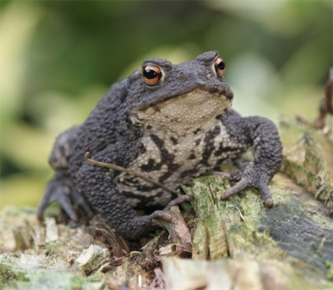
- Orwell refers to a ‘worn-out figure of speech’. How does he make everyday language feel original in Paragraphs 4-5?
- Rhetorical questions are among the most over-used devices. What makes the two rhetorical questions effective in Paragraph 6?
- What makes Orwell’s closing reflection a satisfying ending? Paragraph 8.
- Your conclusion: how has he structured or organised the piece overall to make it entertaining?

Skills? *This will help you deepen your response to non-fiction and your own technique in writing it*

