These tasks will help you prepare a piece of writing to enter the
Orwell Youth Prize, on the theme
‘Coming Up for Air: Writing the Climate Crisis’

Lesson 4: Research

George Orwell did his own research. But he couldn’t rely on YouTube videos. Orwell stayed in the homes of the industrial working class in Depression-era Wigan; he worked among the poorest in London and Paris; he fought in the Spanish Civil War.

Where do you begin?
https://www.bbc.co.uk/programmes/m00049b1  TV David Attenborough with a team of scientists – and great graphics – explains Climate Change: the Facts  https://www.bbc.co.uk/iplayer/episode/p097sbzc/the-people-v-climate-change  Inspirational: 108 People vs Climate Change | https://www.theguardian.com/environment/ng-interactive/2021/sep/25/greta-thunberg-i-really-see-the-value-of-friendship-apart-from-the-climate-almost-nothing-else-matters  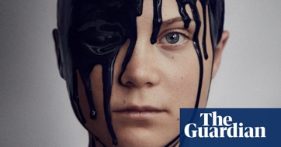  PRINT a candid interview with Greta Thunberg about … everything  https://www.independent.co.uk/climate-change/opinion/climate-crisis-cop26-women-girls-b1954309.html  Natalia Kanem: ‘the impacts of the climate crisis are not gender neutral’
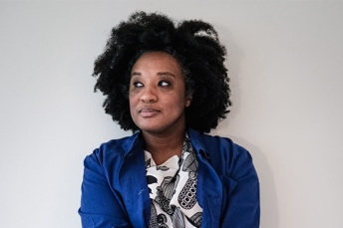  https://thewardrobecrisis.com/podcast  PODCAST a who’s who of fashion and green-ery in 150 episodes  https://www.asustainablelife.co.uk/a-sustainable-life-podcast/  Get inspired by fabulous people doing wonderful things to help us all to live a bit more sustainably | https://www.wwf.org.uk/  ONLINE ‘the world's leading independent conservation organisation’  https://naee.org.uk/  promoting environmental education in the UK for 50 years

Don’t worry, though. No one expects secondary students to travel so far, in space or time. Orwell was also very well-read, with a keen eye for what could be trusted and what was propaganda. You have access to information with an ease and immediacy that Orwell could only have dreamt of. You are also exposed to misinformation in a way that Orwell did dream of … in his nightmares.
Before you research your topic for the Prize, carry out these exercises to help you prepare to get sound, useful information – and fight off the misinformation-makers who are everywhere out there, trying to mislead you.
“Every record has been destroyed or falsified, every book rewritten, every picture has been repainted, every statue and street building has been renamed, every date has been altered. And the process is continuing day by day and minute by minute. History has stopped. Nothing exists except an endless present in which the Party is always right.”
George Orwell, 1984

ACTIVITY

Use Michael Caulfield’s ‘Four Moves’ to assess information on the web.

- Choose two stories from his blog. https://fourmoves.blog/
- Then apply the SIFT technique to each story – and record your results in the table attached. https://www.notion.so/Introducing-SIFT-04db7879dd7a4efaa76bfb2397d11ffd

Research Activity: SIFT

Stop

Investigate the Source

Find trusted coverage

Trace claims, quotes, and media back to the original context

Stop! How do you feel about this story? | Investigate: what did you find out about the Source?
What better trusted coverage did you find?  In what ways was it a better source? | Were you able to trace claims, quotes, and media back to the original context?  What did you find? Did your views change?

What have you learned about research from this exercise?
Share your thoughts with others. What did they think?

Now you are ready – hopefully! – to research your climate crisis topic for your own piece.

Two great places to help you find more …

For the UK:  http://www.field.org.uk/the-top-15-useful-environmental-websites-in-the-uk/ | For the world:  https://en.wikipedia.org/wiki/List_of_environmental_websites

