These tasks will help you prepare a piece of writing to enter the

Orwell Youth Prize, on the 2021-22 theme
‘Coming Up for Air: Writing the Climate Crisis’

The atom bombs are piling up in the factories, the police are prowling through the cities, the lies are streaming from the loudspeakers, but the earth is still going round the sun, and neither the dictators nor the bureaucrats, deeply as they disapprove of the process, are able to prevent it.
Some Thoughts on the Common Toad – published in The Tribune, 1946

George Orwell: the Original Eco-Warrior!

Before it was fashionable to defend nature – and long before scientists had declared a climate crisis – Orwell wrote…

LESSON 2 – read Orwell’s Some Thoughts on the Common Toad –
and identify what makes it effective

- Reading or listening
Read the full text here:
https://www.orwellfoundation.com/the-orwell-foundation/orwell/essays-and-other-works/some-thoughts-on-the-common-toad/
Or listen to Orwell’s son and great grandson read it! It takes 10 minutes – 3 minutes intro and 7 minutes for the essay, which is a little bit shortened. https://www.youtube.com/watch?v=P2tMs3ZZiEM

- Thinking and writing:
How does Orwell fight back against ‘the dictators [and] the bureaucrats’ by writing about a small, everyday creature? (allow up to 45 minutes)
Build your answer, by writing the 6 paragraphs below. For each one, use a quote from the numbered paragraph in Common Toad. (You will need to number the 8 paragraphs!)

- How does Orwell use language at the start of the essay to make the most of the toad emerging in Paragraph 1?
- Orwell is not famous for comedy, but he has a dry sense of humour. How does he use funny description in Paragraph 3?
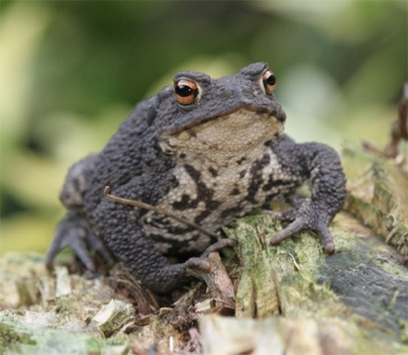
- Orwell refers to a ‘worn-out figure of speech’. How does he make everyday language feel original in Paragraphs 4-5?
- Rhetorical questions are among the most over-used devices. What makes the two rhetorical questions effective in Paragraph 6?
- What makes Orwell’s closing reflection a satisfying ending? Paragraph 8.
- Your conclusion: how has he structured or organised the piece overall to make it entertaining?

