You will work through some tasks to help you prepare a piece of writing to enter the Orwell Youth Prize, on the theme of

‘A NEW DIRECTION: STARTING SMALL’

LESSON 3 – Writing about toads. What else?

- Research: read the text and watch the video (it takes 10 minutes, max):
https://www.nhm.ac.uk/discover/ways-to-help-frogs-and-toads.html
https://www.youtube.com/watch?v=u5HrW9RE8S4

- Task: using the materials from the Natural History Museum, create one of the non-fiction pieces that follow, in 45 minutes*

- Write a speech for your classmates in which you persuade them to help the survival of the common toad – and/or other wildlife OR
- Write a letter to a building developer near you who is planning to get rid of a pond where toads spawn, asking for a re-think

Advice
- Research: make your notes from your reading and watching first.
- Plan: decide what you want to say; then number the points in the best order.
- Write: Orwell begins and ends his essay satisfyingly, makes it amusing, uses techniques to effect and sounds original! How will you write to entertain your reader? (You can look at our style guide for ideas.)

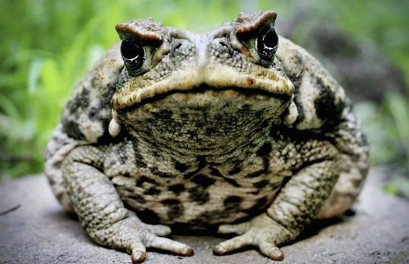
Getty Images
Skills? * Task 3 will give you a chance to develop your own technique in writing non-fiction … and you could even submit it for the Orwell Youth Prize *

